Last night at office hours we discussed how to take the results of our Week 4 assignment and load them into a table for export.

The first thing I did was to assign example results to variables. I did mean, max, and min for Binomial and BN1. I just wanted a sample 3 x 2 matrix.

> mean_Binomial <- mean(Binomial)

> max_Binomial <- max(Binomial)

> min_Binomial <- min(Binomial)

> min_BN1 <- min(BN1)

> max_BN1 <- max(BN1)

> mean_BN1 <- mean(BN1)

Next, I used the data.frame() function

> wk4_results <- data.frame(list(Binomial=c(mean_Binomial, max_Binomial, min_Binomial), BN1=c(mean_BN1, max_BN1, min_BN1)))

> wk4_results

Binomial BN1

1 70.168 9.994328

2 84.000 18.612025

3 57.000 1.781160

I did not like that the rows were not labeled, so I added " "=c("mean", "max", "min")

> wk4_results <- data.frame(list(" "=c("mean", "max", "min"), Binomial=c(mean_Binomial, max_Binomial, min_Binomial), BN1=c(mean_BN1, max_BN1, min_BN1)))

> wk4_results

X. Binomial BN1

1 mean 70.168 9.994328

2 max 84.000 18.612025

3 min 57.000 1.781160

Finally, to export, I used

write.table(wk4_results, "wk4_results.txt")

I used Text to Columns in Excel to clean it up.

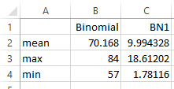

Here is the whole thing:

wk4_results <- data.frame(list(" "=c("Mean", "Median", "Std Dev", "Min", "Max"), Binomial=c(mean_Binomial, median_Binomial, sd_Binomial, min_Binomial, max_Binomial), BN1=c(mean_BN1, median_BN1, sd_BN1, min_BN1, max_BN1), BN2=c(mean_BN2, median_BN2, sd_BN2, min_BN2, max_BN2), ln=c(mean_ln, median_ln, sd_ln, min_ln, max_ln), N1=c(mean_N1, median_N1, sd_N1, min_N1, max_N1), N2=c(mean_N2, median_N2, sd_N2, min_N2, max_N2)))

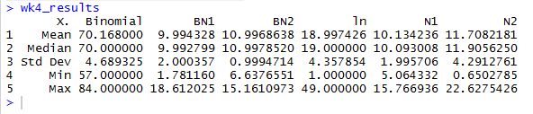

Here are a couple "I coulda had a V-8" refinements.

Use write.csv() instead of write.table() and it will open up in columns in Excel without having to parse the data with Text to Columns.

Here is a better way to do the row labels:

